TERRANEXT GLOBAL VENTURES
AI Intelligence Platform
Installation & Deployment Guide
Document 8 of 8 · Version 1.0
August 2, 2026
CONFIDENTIAL — Prepared exclusively for TerraNext Global Ventures

Document Control
Document Title | AI Intelligence Platform — Installation & Deployment Guide
System | TerraNext Business OS
Classification | Confidential — Client Delivery
Prepared For | TerraNext Global Ventures
Prepared By | Engineering Documentation Team
Status | Final
Related Documents | Technical Architecture Guide; Developer Guide; Operations Manual

Version History
Version | Date | Author | Description of Changes
1.0 | 2026-08-02 | Engineering Documentation Team | Initial release — converted from the Markdown source of truth for client handover.

Table of Contents
Right-click this table and choose "Update Field" → "Update entire table" to populate page numbers after opening this document in Word.

ℹ NOTE
This guide assumes the TerraNext Business OS CRM itself is already deployed, following the platform's general deployment runbook (Doc 24). The steps below cover only what is specific to enabling and deploying the AI Intelligence Platform module — they are not a substitute for that runbook.

1. Prerequisites
- Firebase CLI authenticated against the correct project (firebase login, firebase use <project-id>), per the general deployment runbook.
- If enabling real AI processing (recommended for production; see §3), an account and API key with:
- OpenAI, and/or
- Google AI Studio / Gemini
Either or both, depending on which provider(s) you intend to use for speech-to-text and/or summarization (they are configured independently — see §3).

2. What Gets Deployed
The AI Intelligence Platform ships as part of the CRM's existing Firebase deployment — there is no separate application, project, or hosting target for it.
Component | Deploys via | Notes
Firestore security rules for the module's 6 collections (aiSessions, aiProcessingJobs, aiTranscripts, aiSummaries, aiAnalytics, aiIntelligenceSettings) | firebase deploy --only firestore:rules | Already part of the project's single firestore.rules file — no separate rules file for this module
The one Cloud Function, processAiSessionJob | firebase deploy --only functions (or scoped to functions:processAiSessionJob) | Firestore trigger (onDocumentWritten on aiProcessingJobs/{jobId}); region asia-south1; memory: 1GiB; timeoutSeconds: 540
Storage access | No dedicated rules — the project's single blanket-deny storage.rules already covers this module's audio chunk paths via server-issued signed URLs | Nothing to deploy specifically for this module
Next.js pages, server actions, and UI | firebase deploy --only apphosting (or your platform's app deploy step) | Ships as part of the main application build — no separate build/deploy step
There is no dedicated "install" step beyond a normal CRM deployment — the module activates as soon as its code is present in a deployment. What determines whether it produces real AI output or placeholder output is the environment configuration in §3.

3. Environment Variables & Secrets
The module reads its AI provider configuration through Firebase Functions v2 parameters (firebase-functions/params) — regular configuration values via defineString, and sensitive values via defineSecret (Secret Manager–backed). These are resolved at Cloud Function runtime, not at the Next.js application layer, and are never entered into any CRM screen.
Variable | Kind | Default if unset | Purpose
AI_SPEECH_PROVIDER | defineString | mock | Selects the transcription provider: mock, gemini, or openai
AI_SUMMARY_PROVIDER | defineString | mock | Selects the summarization provider: mock, gemini, or openai
GEMINI_MODEL | defineString | gemini-2.5-flash | Gemini model id, used for both transcription and summarization when Gemini is selected
OPENAI_CHAT_MODEL | defineString | gpt-4o-mini | OpenAI chat model id, used for speaker classification and summarization when OpenAI is selected (transcription itself always uses OpenAI's Whisper model, which is fixed and not configurable)
GEMINI_API_KEY | defineSecret | none | Required if either provider is set to gemini
OPENAI_API_KEY | defineSecret | none | Required if either provider is set to openai

3.1 Setting the string parameters
Following the same convention already used elsewhere in this project's Functions deployment (e.g. FIRESTORE_EXPORT_BUCKET), defineString parameters are supplied via an environment file in the functions/ directory — either a shared functions/.env or a project-specific functions/.env.<project-id> file, which Firebase Functions v2 loads automatically at deploy time. Add the desired values there, for example:
AI_SPEECH_PROVIDER=openai
AI_SUMMARY_PROVIDER=openai
OPENAI_CHAT_MODEL=gpt-4o-mini

Leave a variable unset to keep its default (mock for the provider selectors).

3.2 Setting the secrets
Secrets are never placed in an .env file or committed to the repository. Set each one with the Firebase CLI:
firebase functions:secrets:set GEMINI_API_KEY
firebase functions:secrets:set OPENAI_API_KEY

Each command prompts for the secret value interactively and stores it in Secret Manager. Only set the secret(s) matching the provider(s) you've selected in §3.1 — an unused secret can be left unset.
⚠ WARNING
If a provider is selected in AI_SPEECH_PROVIDER/AI_SUMMARY_PROVIDER but its matching secret is missing or invalid, the module does not fail loudly — it silently falls back to the mock provider, and every session will complete "successfully" with placeholder transcript and summary text. Always verify (§5) after changing this configuration.

4. Deployment Steps
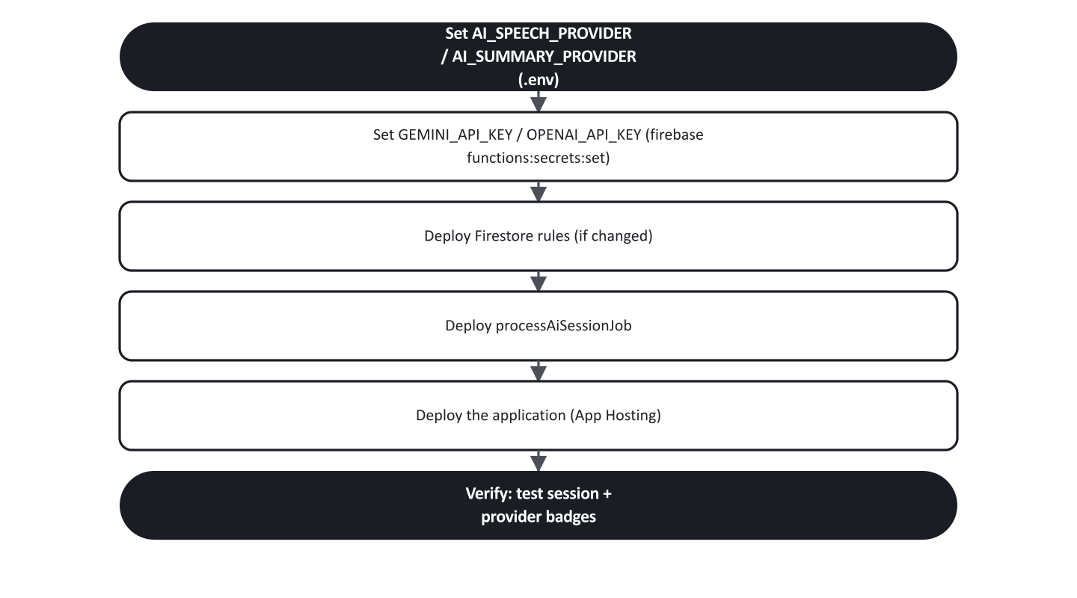
Figure 1. Deployment sequence.
- Complete §3 (string parameters in the functions/.env/functions/.env.<project-id> file, secrets via firebase functions:secrets:set).
- If this is the first deployment of the module, or if firestore.rules has changed, deploy rules first:
` firebase deploy --only firestore:rules `
- Deploy the Cloud Function:
` firebase deploy --only functions:processAiSessionJob ` (Or firebase deploy --only functions if deploying alongside other function changes.)
- Deploy the application (Next.js pages, server actions):
` firebase deploy --only apphosting ` (Or your platform's equivalent app deploy step, per Doc 24.)

5. Verifying the Deployment
- Sign in with a System Administrator or Founder account and open AI Intelligence Platform → Settings.
- Record a short test session (a Trainer, System Administrator, or Founder account can do this) — a minute or two is enough.
- Once the session reaches Completed, reopen Settings and confirm the Active speech provider / Active summary provider badges show the expected provider (openai/gemini), not the default demonstration mode.
- Open the test session's Summary and Transcript tabs and confirm real content was generated rather than the placeholder sentence describing an unconfigured provider.
- If the badges still show demonstration mode or the job failed, see §6 and the debugging checklist in 03 — API & AI Workflow Guide §8.

6. Switching Providers Later, and Rollback
- Changing providers is a configuration-only change: update AI_SPEECH_PROVIDER/AI_SUMMARY_PROVIDER (and the matching secret, if not already set) and redeploy the function per §4 steps 1 and 3. No code changes or data migration are involved — provider selection is independent of any previously completed sessions' stored data.
- Fast mitigation during an incident — if a configured provider is down or misbehaving and you need to stop new sessions from failing while you investigate, set AI_SPEECH_PROVIDER/AI_SUMMARY_PROVIDER back to mock (or simply remove the override) and redeploy. Sessions will complete with placeholder content rather than failing outright, which keeps the recording → processing → completed workflow unblocked for trainers while the underlying provider issue is resolved.
- Rolling back the function code itself follows the same rollback mechanism as any other Cloud Function in this project — see Doc 24 §2.1.

7. Post-Deployment Checklist
- [ ] functions/.env/functions/.env.<project-id> contains the intended AI_SPEECH_PROVIDER/AI_SUMMARY_PROVIDER/model values (or is intentionally left at mock for demonstration use)
- [ ] Matching secret(s) set via firebase functions:secrets:set for any non-mock provider selected
- [ ] firestore:rules deployed and current
- [ ] processAiSessionJob deployed
- [ ] Application deployed
- [ ] A test session was recorded end-to-end and reached Completed with real (non-placeholder) content, if a real provider was configured
- [ ] Settings screen provider badges match the intended configuration
- [ ] Relevant staff informed of which provider is active, per the Operations Manual

